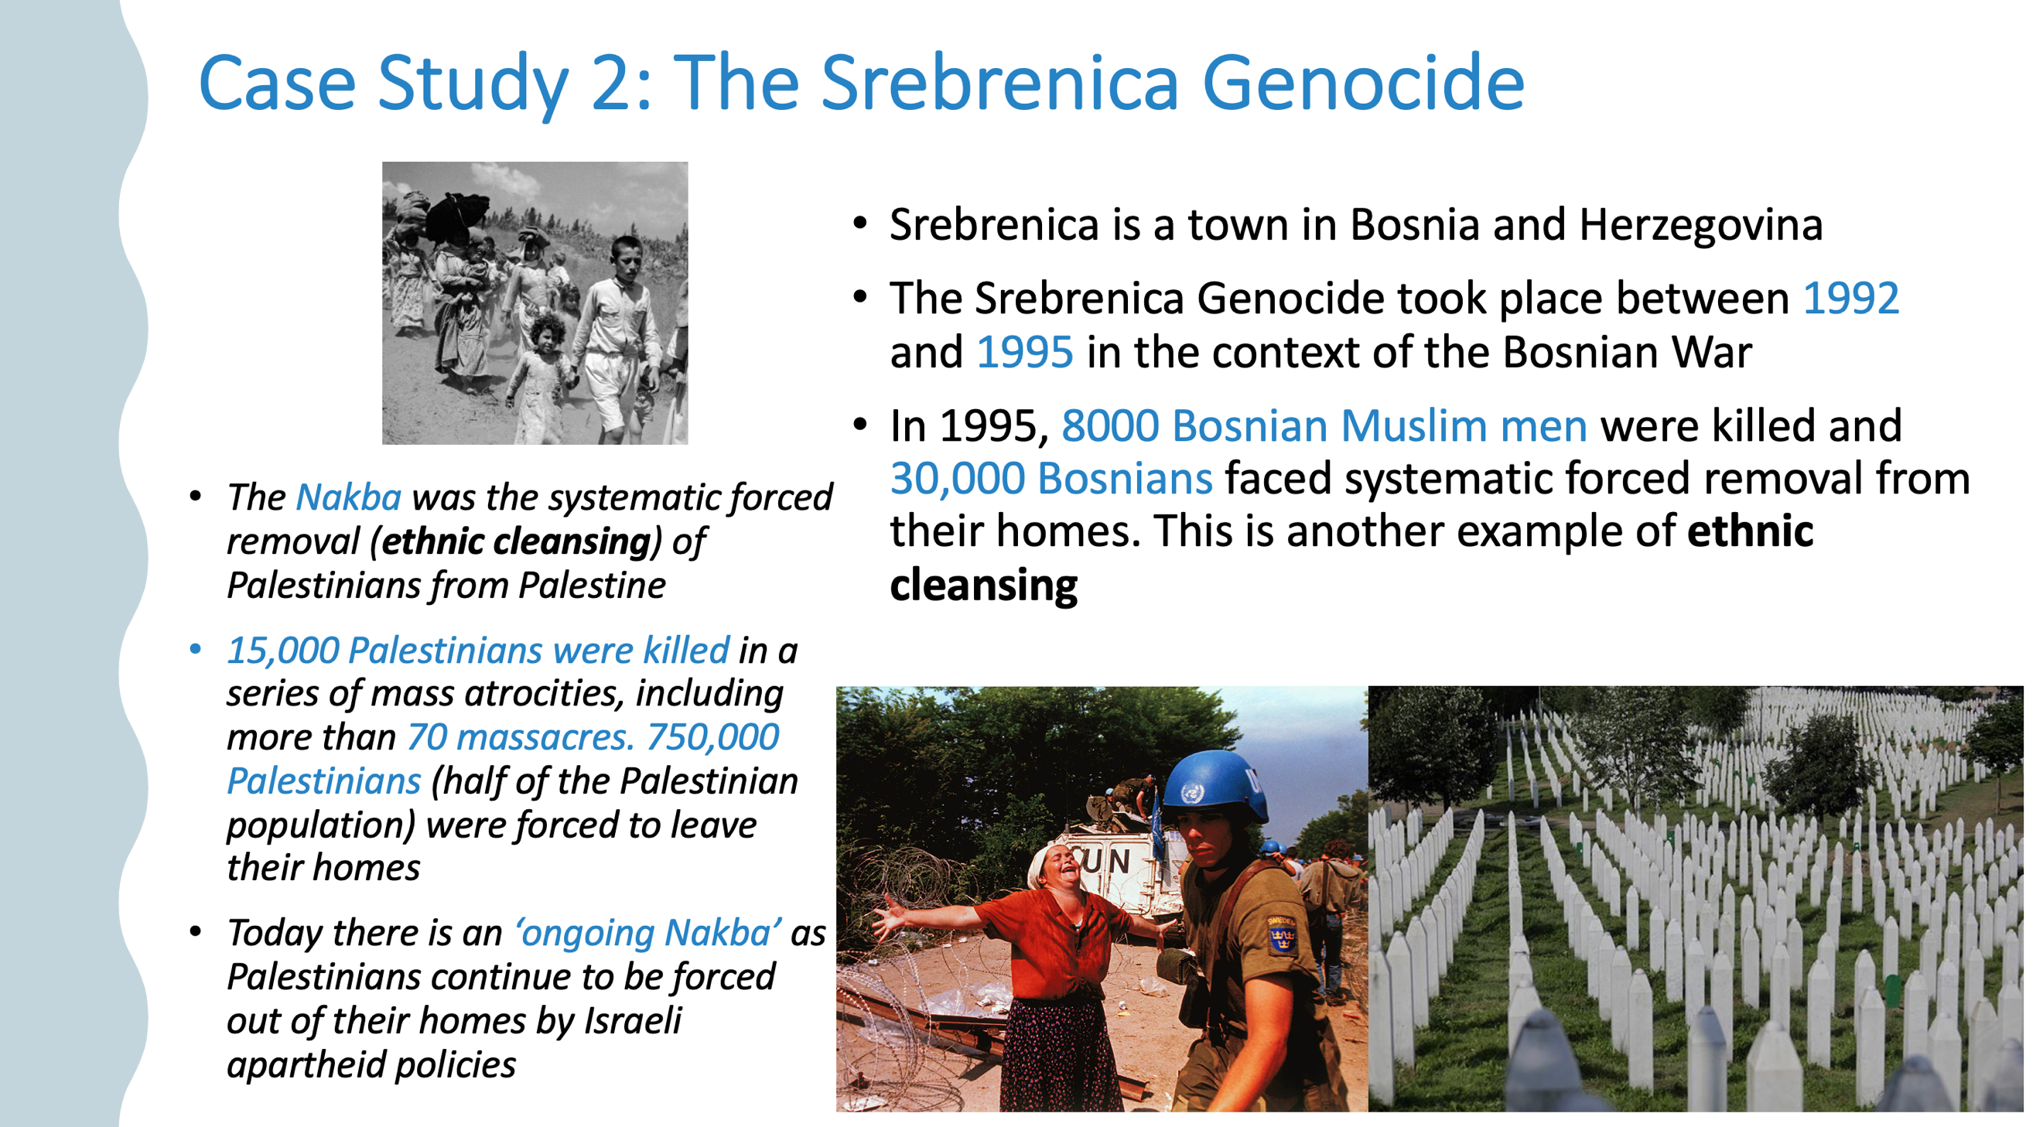

19c. Similarities and differences